PF LAB 11 TASKS

Name: Muhammad Rohaan Roll No: 25K-0026
Date: 26th November, 2025 Section: BAI-1A

-> TASK #1:

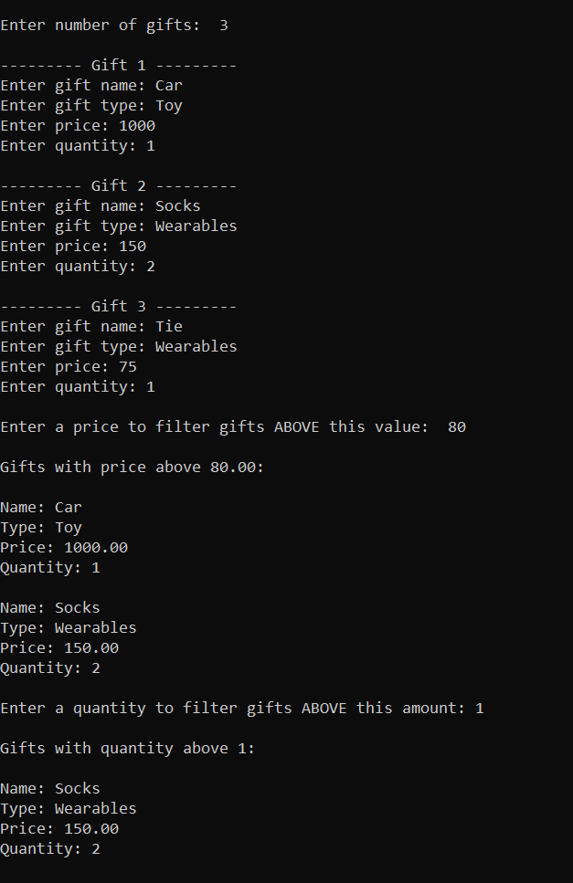
-> TASK #2:

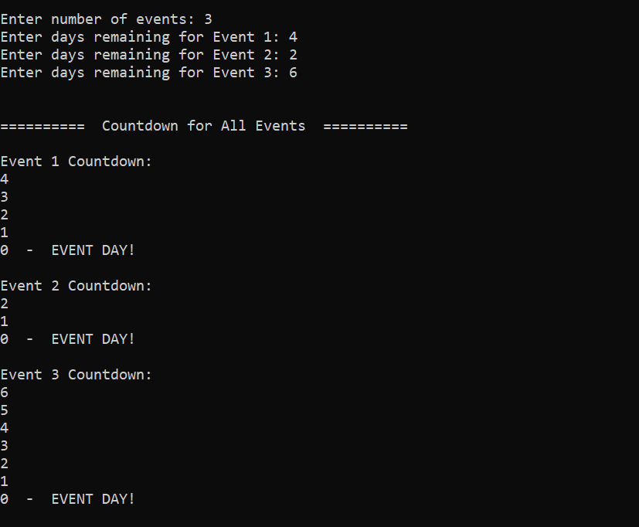
______________________________________________________________________________

-> TASK #3:

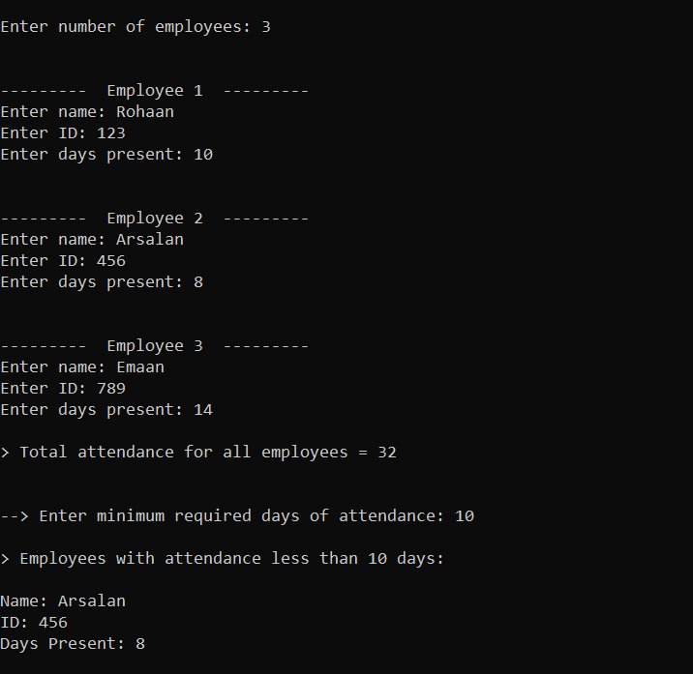
______________________________________________________________________________

-> TASK #4:

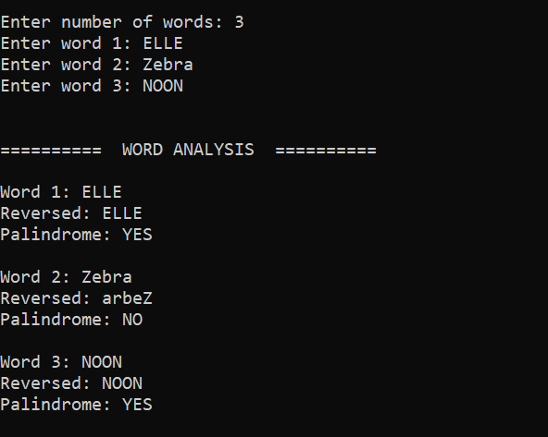
______________________________________________________________________________

-> TASK #5:

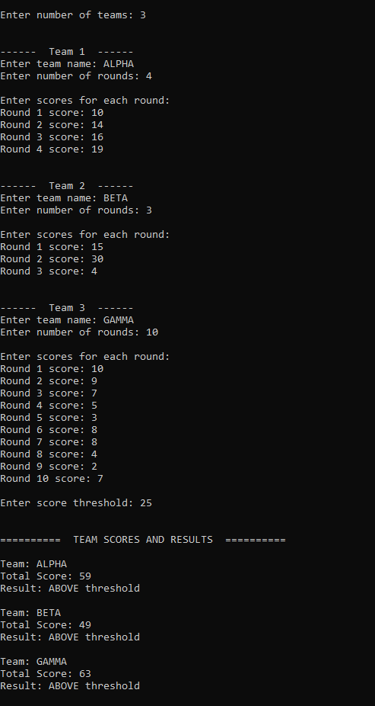
-> TASK #6:

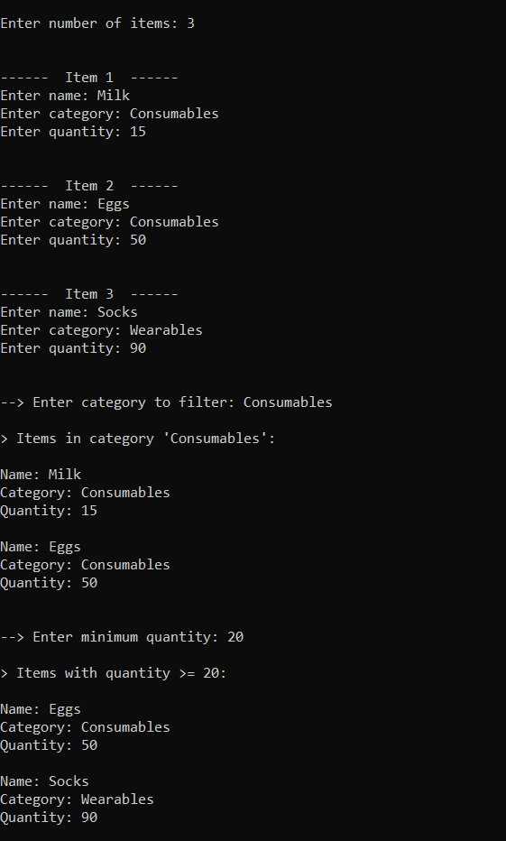
-> TASK #7:




